Harissa Halloumi Hug
Inspired by


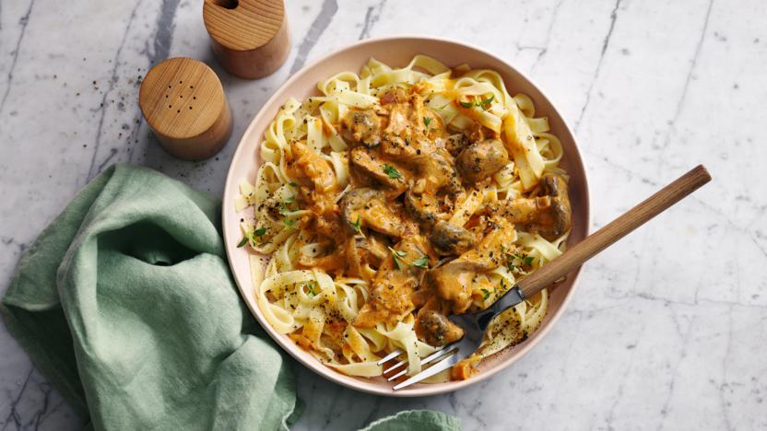
DID YOU KNOW?
“Spice up your life and boost your health with harissa! This fiery chili paste may aid in metabolism, reduce inflammation, fight cancer, improve heart health, and boost immunity. “

Nutrition – Total / Per Serving
Calories: 910kcal / 455kcal
Carbohydrates: 131g / 65.5g
Protein: 30g / 15g
Fat: 26g / 13g
Fibre: 20g / 10g
Sugar: 12g / 6g
Ingredients
1 tin of green lentils
250g of halloumi
125g of baby plum tomatoes
1 red onion
4 cloves of garlic
1 ciabatta
100g of baby spinach
1 vegetable stock
1 tbsp of harissa paste
100ml of water






Good for:

Star Rating:





Method

Step 1 - Preparation
Preheat the oven to 200°c.
Halve, peel, and thinly slice the red onion.
Peel and dice the garlic gloves.
Cut the halloumi into 2cm squares.
Drain and rinse the lentils.
Halve the tomatoes and tear the ciabatta into roughly 2cm chunks.

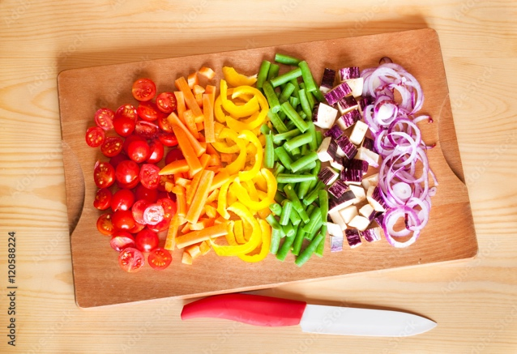

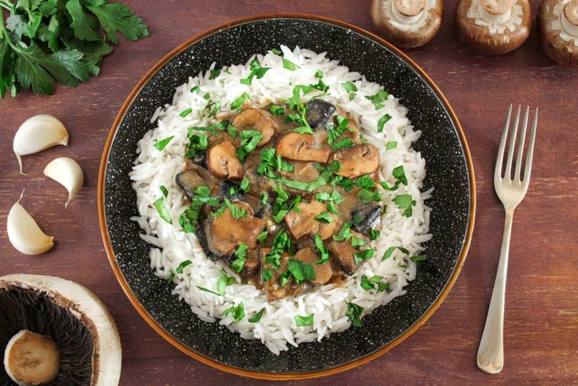
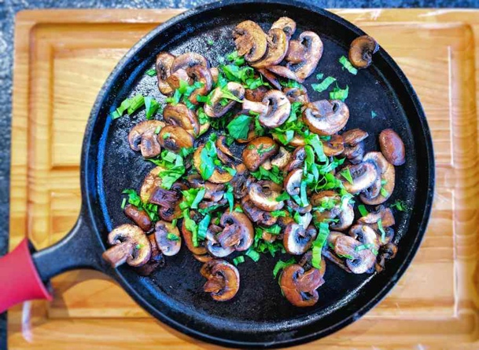
Step 4 – Bring it Together
In a separate frying pan, heat oil and add the halloumi.
Fry until golden (~3mins each side).
Serve the harissa lentils into a bowl and add the halloumi.
Scatter the toasted ciabatta on top.

Enjoy!
Step 3 – Harissa the lentils
Take out the tomatoes and ciabatta.
Add the water and vegetable stock into the frying pan.
Bring to the boil then reduce the heat and simmer. (~2mins)
Add the lentils and harissa paste to the frying pan.
Bring the pan back to the boil and cook. (~2mins)
Add the spinach and cook until wilted. (~2mins)
Take off the heat and add the tomatoes, set aside to rest.
Step 2 – Bake & Fry
Place the tomatoes and ciabatta on a baking tray and drizzle some oil on top. Add salt & pepper if desired.
Place them in the over until the ciabatta is golden. (~8-10mins)
Meanwhile, heat oil in a frying pan and add the red onion.
Season the red onion with salt & pepper.
Fry the red onion until softened. (~7-8 mins)
Add the garlic and cook for another minute.

